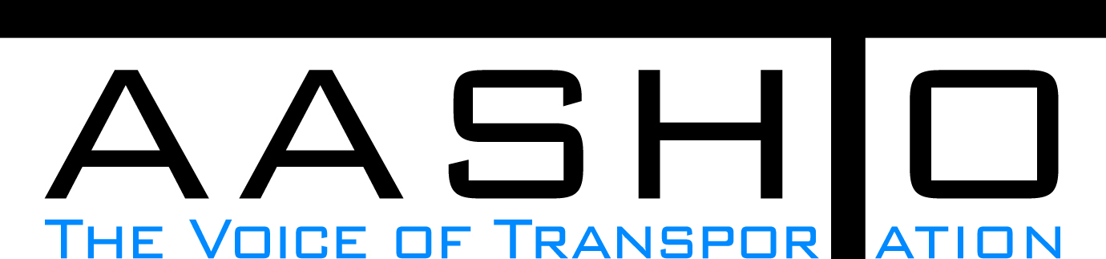Domestic Scan Proposal Form
AASHTO is soliciting topic proposals for a Calendar Year 2013 US Domestic Scan Program (NCHRP Panel 20-68A). Each selected scan topic will be investigated through site visits to three to six locations for approximately a two week period or less (type 1), by webinar (type 2) or peer exchange (type 3) conducted by a group of eight to 12 transportation professionals with expertise in the selected topic area. Proposed topics should meet the following criteria:
- Address an important and timely need for information by transportation agencies;
- Are of interest to a broad national spectrum of people and agencies;
- Are complex and also “hands-on,” meaning they lend themselves particularly well to exploration through on-site visits; and
- Are sufficiently focused that the tour participants are able to investigate and understand key issues in the limited time available on the tour.
This form is designed to collect the full length of your proposal. Sections requiring essays have unlimited space for you to use. Contact information has some limited text. Use your TAB key to advance to the area where you need to complete information.
Proposals should be returned no later than OCTOBER 15, 2012.
Proposal Contact Information
Name | Richard Manser | Address | 4501 South 2700 West Box 148380 Salt Lake City, UT 84114-8380
Title | Statewide Utilities Engineer | E-mail | rmanser@utah.gov
Member Department | Utah DOT | Telephone number | 801.965.4083
AASHTO Committee |  | Date of submission | 8/13/2012

Title of Proposed Scan

Utility Tracking And Management Systems

Problem Statement (What topic is to be examined? What drives the need for the scan? Why now?)
What are Best Practices for storing survey grade location data and accessing the data through a GIS interface? Utility location data can be collected during installation of utilities either when initially installed or as part of protection/relocation associated with a highway project. How are states storing these data and have they developed GIS interfaces to retrieve and use the data? There is an interest in using utility location data to manage encroachment requests on the right-of-way and as an aide to designers working on future highway projects.

Scan Scope (What specific subject areas are to be examined? Which cities and states might be visited? Which agencies/organizations (including specific departments or types of staff if applicable)?
Determine data collection requirements (format, quality control, certification, etc.). Determine storage/retrieval and data system requirements and level of effort to maintain the system. Determine ‘friendliest’ user-interfaces and most common methods of user interaction with the system. Determine level of cooperation/participation by utility owners and typical implementation issues. Assess benefit/cost of operational systems – numerical and anecdotal. Texas and North Carolina may have established systems. Visit with municipal offices and state DOTs. Discuss with permit officers, roadway design managers, systems development managers, utility coordinators/officers.

Anticipated Scan Results (What key information is to be gained? What information is to be shared after the scan? Who would the audience be for this information?)
Best practices and lessons learned from implementing these systems would be shared with all State DOTs and other public agencies considering or in process of implementing similar systems.

Benefits Expected (Including potential impacts on current technology or procedures)
Support for or against implementing systems by learning about successes, challenges, methods or procedures and costs. Learn about technical tools best suited for these systems.

